Canada Rugby League Referees Association

JUDICIARY REPORT FORM

Official: |  | Date:
Were you the referee or touch judge for the game this incident report is for:
Match: |  | v
Age: |  | Division:
Player: |  | Jersey no:
Registration no: |  | Club:

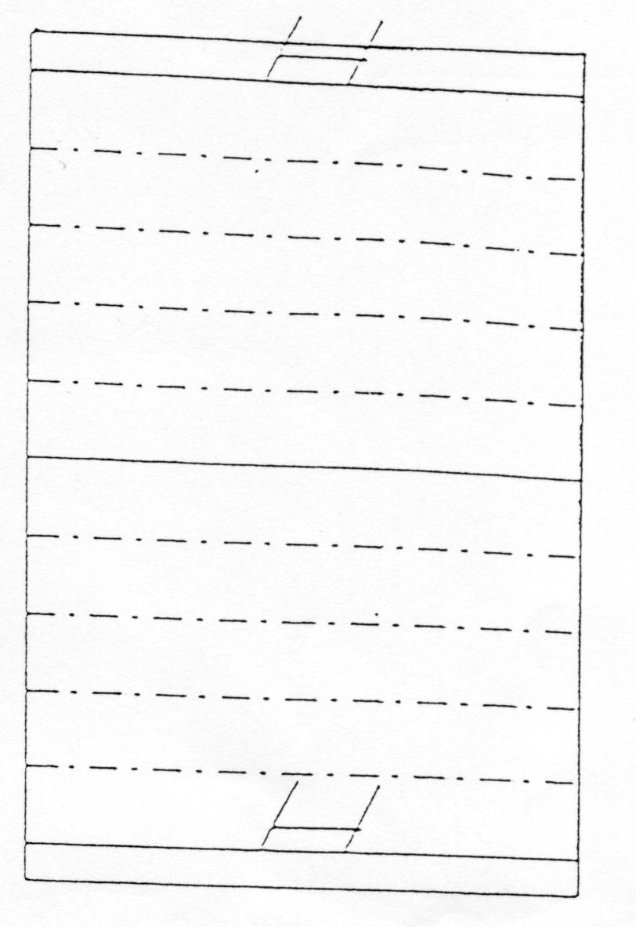
Charge(s): Place an X in the box of the charge(s) that apply

 | Trips, kicks or strikes another player |  | Uses offensive or obscene language
 | Specify: |  | At referee or tough judge
 | When effecting or attempting to effect a tackle makes contact with the head or neck of an opponent intentionally, recklessly or carelessly |  | Disputes decision of the referee or touch judge  TIME
 | Drops knees first to an opponent who is on the ground |  | Re-enters the field of play without the permission of the referee or touch judge having previously temporarily retired from the game
 | Uses any dangerous throw when affecting a tackle |  | Behaves in any way contrary to the true spirit of the game
 | Deliberately and continuously breaks the laws of the game. |  | Deliberately obstructs an opponents who is not in possession

TJ
X
R
TJ
On the diagram to the right:-
The timekeepers table has been marked with “TIME”. You are to mark the position of the incident with the “X”, the referee’s position with “R” and if any touch judges were involved mark their positions with “TJ”.
You do this by hovering your mouse over the boxes above until you see 4 little arrows and then clicking on it and dragging them on the diagram.

Referees view of the incident: (Clear, Obstructed etc)
Touch Judge(s) view of the incident: (if applicable)
Time of incident in game:

Details of incident:

